Michelle Babcock
Keep Stepping Home Exercise Program

Sandy is a 71-year-old married woman who enjoys gardening. She has a chief complaint of loss of shoulder ROM. In addition, she complains of tight hamstrings, low back pain with movement, and would like to improve her core strength and posture. Sandy states, she had a left hip replacement several years ago but could not remember the year. She is on several physician managed medications for A-fib, high cholesterol, and ankle edema. She is a returning Keep Stepper and enjoys the program and has made several friendships. She continues to stay active by working outdoors in all four seasons, by shoveling, raking, and maintaining her gardens. She likes to dance and made a comment about how she can dance for 6 hours at a wedding but does not like walking just to walk. She finds that to be pointless. Sandy and her husband are planning to move out of their home and into a smaller place in the near future.
Long Term Goal: Within this session of Keep Stepping, Sandy will demonstrate an increase in upper body flexibility with an improved back scratch test, this will allow her to keep her shoulders back and open, helping her to maintain a more upright posture so she can continue to be active and working in her gardens.
I chose the research article Association between back muscle degeneration and the spinal-pelvic parameters in patients with degenerative spinal kyphosis from the BMC Musculoskeletal Disorders (2019 20:454). While Sandy has not been formally diagnosed with degenerative spinal kyphosis (DSK), she does fit the definition of DSK. DSK is said to be a common occurring spinal deformity in adults over 40, with degenerative being effects of age and wear/tear on the body, and according to Google kyphosis is excessive outward curvature of the spine, causing hunching of the back. 22 female and 10 male patients with DSK were included in this study, which includes reviews of whole spine X-rays and lumbar MRIs dating March 2016 to May 2018. MRI was then performed, and measurements taken from L1/2 to L5/S1, the muscles specifically measured were multifidus, erector spinae, and psoas. This study provides a correlation between the size of lumbar muscles and patients with DSK, it did not compare the lumbar muscles of healthy patients. While the study did not address specific exercises, it did conclude that the lumbar spine muscles; multifidus, erector spinae, and to a lesser degree psoas play a role in helping to maintain the sagittal balance of the spine. This study helped me to feel good about using upper back exercises but also adding lower back and core exercise which may be weak and explain Sandy’s low back pain.
When I was a new personal trainer, I felt I needed to develop my own programs and I spend a lot of time stressing and struggling with putting programs together. As time went on, I learned KISS (keep it simple, stupid) and that I don’t need to reinvent the wheel. I could find programming (someone already did the work) and adjust to fit my clients needs. For Sandy, I found an article from SilverSneakers, I would have been able to use it for both an education article and it also provided 6 exercises to “prevent the dreaded hunchback”. This program included upper back strength, lower back, and core. Perfect from what I learned from my research article. I asked Sandy to work on a stretch for her pectoral muscles and to help open up her shoulders over spring break. She was instructed to reach her arms out to the sides bringing them behind her back until she felt a stretch (no pain) in the front of her shoulder. She was to repeat that 2-3 times a day, holding the stretch for 10 secs for 5 reps. I was then planning to add/ instruct one or two exercises a week, assessing if Sandy would be able to complete each exercise at home safely.
Home Exercise for Sandy
- Shoulder Squeeze- 2 sets of 12-15 reps
- Dead Bug- 2 sets of 6-8 reps
- Bird Dog- 2 sets of 6-8 reps
- Hip Hinge- 2 sets of 10-12 reps
- Bent-Over Row- 2 sets of 8-10 reps with light weights
- Step-up- 2 sets of 8-10 reps

I would have provided Sandy with 3 education topics; lumbar strain, preventing dreaded hunchback, and coronavirus- what older adults need to know. Sandy had complained about some low back pain and I wanted to give her a better understanding of what and why she might be experiencing this. The Medbridge patient education article for lumbar strain gives her a very brief explanation, I would have tied it to the home exercises I would have prescribed. In this crazy time, I would have like to educate Sandy on the Coronavirus. From what I have learned of Sandy, she does not let things like rules or suggestions slow her down. I believe it would have been helpful to emphasize the need for safety for her and her husband. My last education was on preventing hunchback. She has seen a decrease in her shoulder ROM and can tell her posture has be suffering, this was her main goal for keep stepping.
It is hard to believe how much the world has changed since the beginning of the semester, Covid-19 has essentially shut everything down. I believe it was in the best interest of our clients to discontinue the program, until we can understand the virus and provide a safe environment. Unfortunately, I was unable to get a hold of Sandy, nor did she return my phone calls when the program was cancelled. I could not provide her with the home education materials. I believe Sandy would have benefitted from the home exercise program and the educational topics. These tools would have helped to inform and provide guidance. Following the program would encourage her to open her chest with stretches and strengthen her back, both would have help to prevent a further decline in her shoulder ROM if not help to improve it. This would have been seen in her post-session fitness testing, most notable her back-scratch test.

References
6 Best Exercises to Prevent the Dreaded Hunchback. SilverSneakers. https://www.silversneakers.com/blog/best-exercises-prevent-dreaded-hunchback/. Published November 26, 2019. Accessed March 26, 2020.
Coronavirus: What Older Adults Need to Know to Stay Healthy. SilverSneakers. https://www.silversneakers.com/blog/coronavirus-covid-19-what-seniors-should-know/. Published March 25, 2020. Accessed March 26, 2020.
Lumbar Strain. Medbridge. https://www.medbridgeeducation.com/patient-education-library/condition/2482-Lumbar-Strain. Accessed March 27, 2020.
Xia W, Fu H, Zhu Z, et al. Association between back muscle degeneration and spinal-pelvic parameters in patients with degenerative spinal kyphosis. BMC Musculoskeletal Disorders. 2019;20(1). doi:10.1186/s12891-019-2837-0.

6 Best Exercises to Prevent the Dreaded Hunchback
By K. Aleisha Fetters | August 27, 2018

Stand taller and stronger—for longer!—with this simple workout.
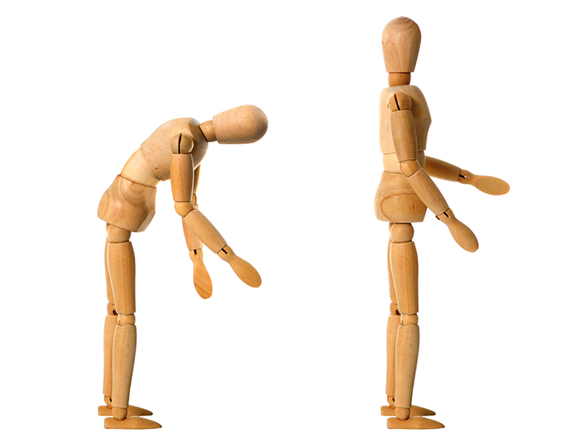
At one point or another, you’ve undoubtedly seen an older adult with a severe case of hunchback. Their upper back is rounded, their face points toward the floor, and their movements seem labored and painful.
Called kyphosis, the condition—in which the upper spine takes a C shape—affects between 20 and 40 percent of older adults, with prevalence and severity increasing as you get older, says research published in the Journal of Orthopaedic and Sports Physical Therapy. Kyphosis can limit mobility, cause pain, and increase the risk of falls.

What Causes Kyphosis?
Weakness in the core muscles and upper back as well as a history of maintaining poor posture can all contribute to kyphosis. However, the greatest cause of the spinal condition in older adults is actually osteoporosis, explains Jeremy S. Smith, M.D., a spine surgeon at the Hoag Orthopedic Institute in Irvine, California.
“Osteoporosis weakens the bones and makes them susceptible to compression fractures,” Dr. Smith says. That is, the bones in the spine, called vertebrae, can break.
“When severe, something as simple as lifting or coughing can cause a compression fracture, which commonly leads to a collapse of the front of the vertebral bone,” Dr. Smith explains. “When this occurs at multiple levels, it can lead to severe kyphosis.”
Also, as you get older, degenerative disc changes can cause the spinal vertebrae to collapse onto one another, says Leigh Ann Ibrahim, P.T., a physical therapist at Orlando Health South Seminole Hospital in Longwood, Florida.
“The vertebrae become more wedge-shaped instead of their normal cylindrical, stacked shape,” she says.

What You Can Do to Relieve or Prevent Kyphosis
In cases of existing kyphosis, adults can improve spinal alignment by doing exercises that strengthen the abdominals and the extensor muscles in the back (the ones that help you stand and lift objects). However, surgery is needed to correct severe spinal deformities, Ibrahim says.
If you think you might have kyphosis or osteoporosis, make an appointment with your doctor to discuss the best next steps.
As with all health conditions, “the best way to treat kyphosis is to prevent it from happening in the first place,” Dr. Smith says.
And that requires addressing the multiple factors that can contribute to its development, from poor posture to muscle imbalances to osteoporosis, adds Michael Silverman, P.T., director of rehabilitation and wellness at Northern Westchester Hospital in New York.
The workout below helps address all of those things. It’s specifically designed to help strengthen the muscles of the core and upper back, improve posture, and load the body through standing, weight-bearing exercises that help increase bone density and prevent osteoporosis in the spine.
What else can help: Make sure you’re getting enough calcium and vitamin D, which are vital to strong bones, and avoid tobacco products, which can increase your risk of osteoporosis.

How to Do This Workout
To help beat the dreaded hunchback, do each exercise below in order for the suggested number of reps and sets. For best results, perform the full workout two to three times per week.
As always, safety is key. The exercises here may be different or more advanced than those you’ll experience in a SilverSneakers class. If you have a chronic condition, an injury, or balance issues, talk to your doctor about how you can exercise safely.

Exercise #1: Shoulder Squeeze
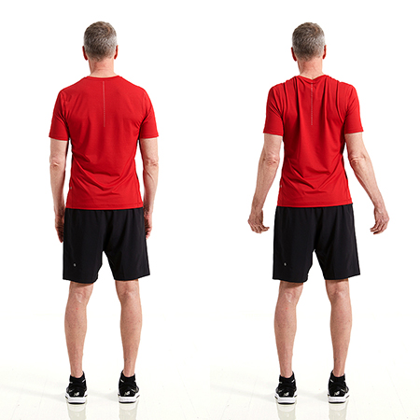Do 3 sets of 12 to 15 reps
Stand tall with feet hip-width apart. While pulling your elbows back and down, squeeze your shoulder blades together. Imagine you’re squeezing a lemon between your shoulder blades. Pause, then release. That’s one rep. Complete a total of three sets of 12 to 15 reps, resting for 30 to 60 seconds between sets.

Exercise #2: Dead Bug
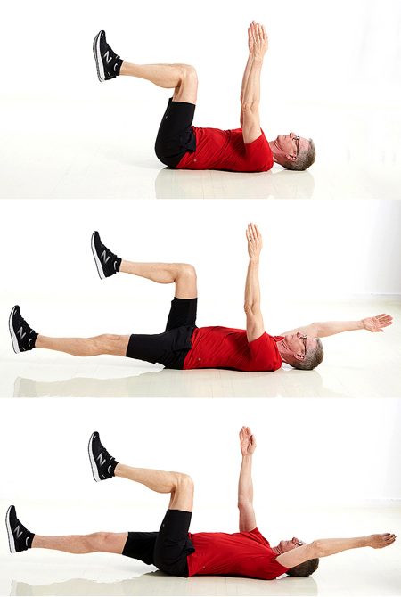
Do 3 sets of 6 to 8 reps
Lie on your back with knees bent and feet flat on the floor. Raise your bent legs up so that your knees are stacked over your hips, keeping a 90-degree bend in your knees. Brace your core to press your low back into the floor; make sure to maintain this flat-back position throughout the entire exercise. With your palms facing each other, bring arms up to point toward the ceiling.
Straighten your left leg and bring it toward the floor (try not to let it touch). At the same time, bring your right arm back toward the floor (try not to let it touch). Pause, then bring your arm and leg back to the starting position. Repeat on the opposite side with right leg and left arm extended. That’s one rep. Alternate sides for six to eight reps total. Do three sets, resting for 30 to 60 seconds between each.

Exercise #3: Bird Dog
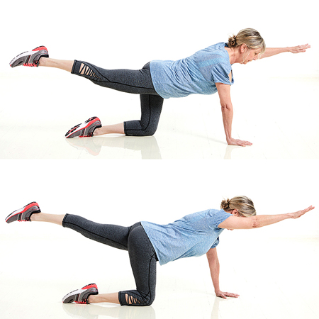Do 3 sets of 6 to 8 reps
Start on all fours with your hands below shoulders and knees below hips. Engage your abs, keep your spine neutral, and gaze down or slightly forward.
Lift your left arm and extend your right leg until they are in line with the rest of your body. Pause, then lower back down, and repeat on the opposite side with right arm and left leg extended. That’s one rep. Perform three sets of six to eight reps, resting for 30 to 60 seconds between sets.
Make it easier: Keep your hands on the floor, and only extend your leg.

Exercise #4: Hip Hinge
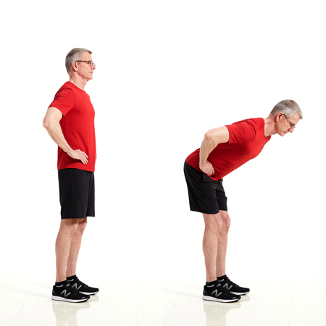
Do 3 sets of 10 to 12 reps
Stand with your feet hip-width apart, knees slightly bent, and hands on hips. With your weight in your heels, push your hips back behind you, and hinge forward. Continue bending at the hips until your torso is at about 45 degrees, or halfway between upright and parallel to the floor.
Squeeze your rear, push your hips forward, and slowly raise your torso back to the starting position. That’s one rep. Perform three sets of 10 to 12 reps, resting for 30 to 60 seconds between sets.

Exercise #5: Bent-Over Row
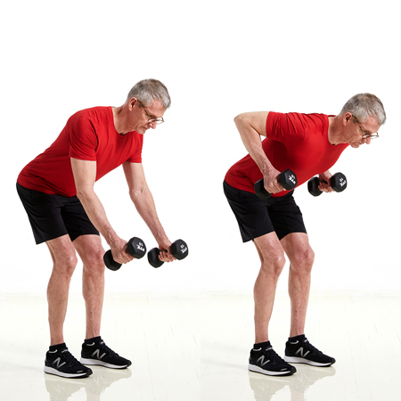
Do 4 sets of 8 to 10 reps
Grab a pair of dumbbells, and stand tall with your feet shoulder-width apart. Pushing your hips back and allowing your knees to bend slightly, lower your torso until it’s almost parallel with the floor. Let the dumbbells hang at arm’s length from your shoulders, palms facing in.
From here, squeeze your shoulder blades together as you bend your elbows and pull the dumbbells up to the sides of your torso. Pause, then slowly lower the dumbbells to return to the starting position. That’s one rep. Perform four sets of eight to 10 reps, resting for 30 to 60 seconds between sets.
Make it easier: Try the seated row machine.

Exercise #6: Stepup
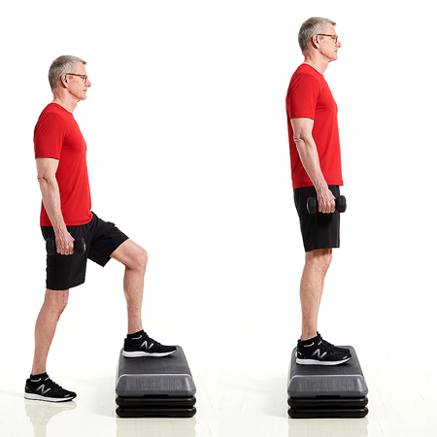
Do 2 sets of 8 to 10 reps per side
Grab a pair of light dumbbells, and hold them at your sides with your palms facing your body. Stand in front of a step. Start with a low step, increasing the height for a challenge.
Set your left foot on the step, push down through your heel, and lift yourself up until your leg is straight. Make sure you do all the work with the leg on the step rather than pushing off the floor with the other.
Step down. That’s one rep. Perform eight to 10 reps or as many as you comfortably can, then repeat on the opposite side. Do two sets total, resting for 30 to 60 seconds between each.

Coronavirus: What Older Adults Need to Know to Stay Healthy
By Nancy Fitzgerald | March 24, 2020

The new coronavirus disease (COVID-19) has upended daily life, but there’s a lot you can and should do to protect yourself.

All around the world, the new coronavirus disease (COVID-19) has grabbed our attention—and for good reason. This respiratory illness can spread easily from person to person, and serious cases can lead to pneumonia and hospitalization.
“Our understanding is evolving day by day,” says Gary LeRoy, M.D., president of the American Academy of Family Physicians. “One thing’s for sure: It’s a serious virus, so we all need to take the necessary precautions.”
If you’re 65 years or older, you should know you’re at higher risk. That’s because the older you get, the less robust your immune system is likely to be. You may have a tougher time shaking off any virus, including coronavirus, than you would at 20.
“Plus, when you get to a certain age, you’re more likely to have accumulated some other health conditions, which can complicate the way the virus acts in your body,” says Dr. LeRoy.
In other words, if you have heart disease, diabetes, lung disease, or any other condition and you get sick from coronavirus, you may have more serious complications than someone who doesn’t have a condition.
Scary? Yes—we’re all human. But experts stress there’s a lot you can and should do to protect yourself. Here’s what to do right now, as well as steps to take should you get sick.

What Everyone 65+ Should Do
Because there’s currently no vaccine for coronavirus and because it spreads easily, prevention should be at the top of everyone’s minds, according to the Centers for Disease Control and Prevention (CDC). For older adults, it’s vital—and potentially lifesaving—to put them into practice. Here’s what the CDC recommends.

Avoid Crowds of All Sizes
Even if your community is not experiencing an outbreak at this time, this currently means skipping the mall, the gym, and activities at your local community center. In fact, many of these locations may close temporarily to slow the spread of coronavirus.
If there are cases in your area, your local health officials may have more specific instructions. Check your local news, or with your state or local health department. You can find information for state health departments here.
Worried about missing out on exercise or social opportunities? Good news: If you’re a SilverSneakers member, you can take advantage of free SilverSneakers On-Demand workout and nutrition videos. Plus, check out these ideas to stay socially connected—from afar.

Keep Your Distance
Whether you call it “social distancing” or “physical distancing,” this means putting about six feet between yourself and others as much as reasonably possible. If you need to pick up groceries, medications, or household essentials, try to go when it’s less crowded, or ask a loved one for help.

Wash Your Hands Often—and Correctly
Lather up with plain soap and water of any temperature, and gently scrub your hands together for at least 20 seconds. Don’t forget the back of your hands, between your fingers, and under your nails. Finish by drying your hands.

Mind the Germ Hot Spots
At home, disinfect “high-touch” surfaces, such as doorknobs, light switches, counters, tables, faucets, toilets, and remotes. For any “disinfecting” products, follow the instructions for best results.
If it’s necessary to leave the house—say, your doctor says you need to be seen in person—minimize contact with door handles, elevator buttons, and the like. Cover your hands with a tissue, and wash your hands afterward.

Postpone Travel
Whether you were planning to go on a cruise, fly to another country, or hop on a train to another state, you may need to rearrange your plans. Currently, the CDC recommends older adults avoid cruises and nonessential flights.
Ships and ports, planes and airports, and trains and stations tend to be exceptionally crowded places, so there’s a high risk of coming into contact with people and their germs. And if you’re going somewhere remote, it may be harder to get medical care if you get sick.

If You Have Heart Problems
High blood pressure (a.k.a. hypertension) or heart disease can increase your risk of developing serious complications if you get infected with coronavirus, according to the American Heart Association (AHA).
In the earliest cases, 31 percent of people who were hospitalized with COVID-19 had high blood pressure, and almost 15 percent had cardiovascular disease, according to JAMA.
“Coronavirus can lead to buildup of fluid in the lungs, and that puts greater strain on the heart,” explains Manish Trivedi, M.D., director of infectious diseases at AtlantiCare, a health system in New Jersey.
What to do: Be sure you’re up to date on your pneumococcal vaccine, and continue taking your prescribed medications. See the AHA coronavirus recommendations for heart problems here.

If You Have Diabetes
Whether you have type 1 or type 2 diabetes, high blood sugar levels can weaken your immune system and make it harder to treat viral infections, like coronavirus, says Dr. Trivedi.
Viral infections can also increase inflammation in people with diabetes, according to the American Diabetes Association (ADA). And a combination of inflammation and high blood sugar can put you at risk for more serious complications.
What to do: Take extra care to manage your blood sugar, and review or ask for your “sick day” plan from your doctor. Have medications and testing strips on hand, as well as simple carbs like soda or hard candies in case your blood sugar gets too low. See the ADA coronavirus recommendations for diabetes here.

If You Have Lung Disease
Coronavirus causes respiratory illness, so it may hit people with chronic obstructive pulmonary disease (COPD), asthma, or other lung problems especially hard, according to the American Lung Association (ALA).
“These people already have impaired breathing,” says Dr. Trivedi.
What to do: Have supplies of any medications on hand, and know how to use your inhaler if you have one. Review or ask for a “COPD action plan” or an “asthma action plan” from your doctor so you know what to do if your lung symptoms flare up. See the ALA coronavirus recommendations for lung disease here.

What to Do If You’re Sick
The CDC recommends watching for three key symptoms of coronavirus:
- Fever
- Cough
- Shortness of breath
If these seem familiar, it’s because they unfortunately mirror some of the top signs of cold or flu. Because of the overlap, it’s important that you call your doctor if you begin to experience any of these signs or if your existing symptoms get worse.
Explain your symptoms, and follow any advice you get to a T, says Dr. Trivedi. You will be given instructions that are specific to your health needs, including if you should go to a medical facility and any safety steps you need to take before going.
Because coronavirus spreads easily, do not go to your doctor’s office without calling ahead first. If you have it, you could pass it on to others. If you don’t have it, you could catch it from someone else.

When to Get Emergency Help
The CDC also recommends getting immediate medical care if you have these coronavirus warning signs:
- Difficulty breathing
- Persistent pain or pressure in the chest
- New confusion
- Bluish lips or face
- Any other emergency signs your doctor has indicated
Call 911, and be as specific as you can about your symptoms. Follow any instructions they give you.

HOME » PATIENT EDUCATION LIBRARY » LUMBAR STRAIN

Lumbar Strain

Print Handout
Provide Feedback

Description:
A lumbar strain is a common and painful condition of the muscles or tendons that support the low back area of the spine. The bones and muscles of our back are supported by ligaments and tendons.
A lumbar strain occurs when the muscles or tendon fibers in the low back are torn, either suddenly or gradually from use over time. When a strain occurs, the surrounding soft tissues become inflamed, making movement painful and difficult.
A common cause of lumbar strain is bending or twisting at the spine instead of using your hips and legs while performing everyday activities. Sitting with poor posture over long periods of time, or participating in activities that involve repetitive bending or twisting, may also lead to a lumbar strain.
Symptoms of a lumbar strain include stiffness and pain in the low back area. Muscle tightness and spasms in the low back and buttocks may also occur. The pain may make it difficult to sit or stand for long periods of time, however rest often temporarily reduces the pain.
Therapy can decrease the pain in your low back and restore motion and mobility. You will be given a home program that includes exercises to reduce stiffness and improve your strength and range of motion. You will also learn correct lifting techniques and healthy ways to move during daily activities.

